

SUBJECT CODE: CSF3023

SUBJECT NAME: WEB-BASED APPLICATION DEVELOPMENT LAB REPORT : 6

|  |  |
| --- | --- |
| NAME | MATRIC NO. |
| MUHAMMAD AMIR FAKHRIE BIN MOHD ZAMRIE | S65453 |

Task 1 Output

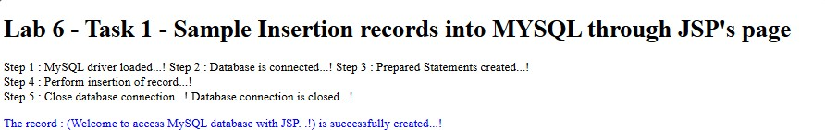

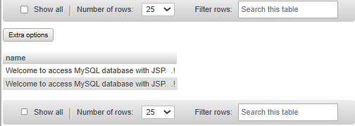

Code:

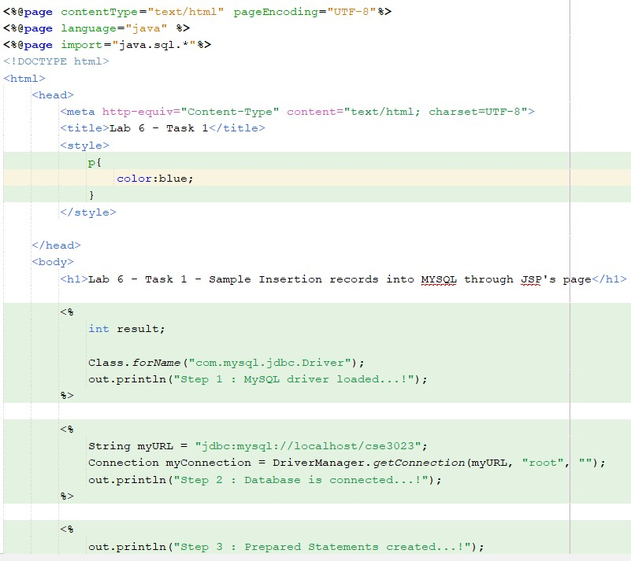

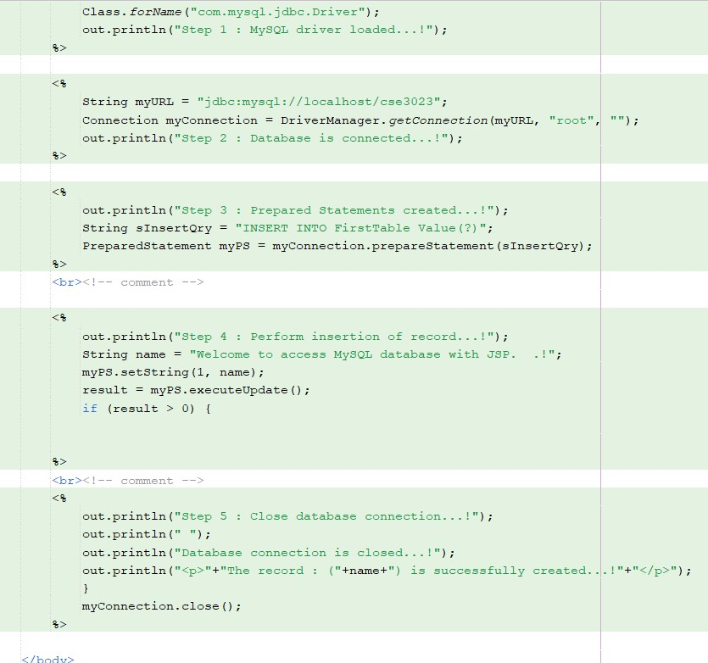

Task 2 Output:

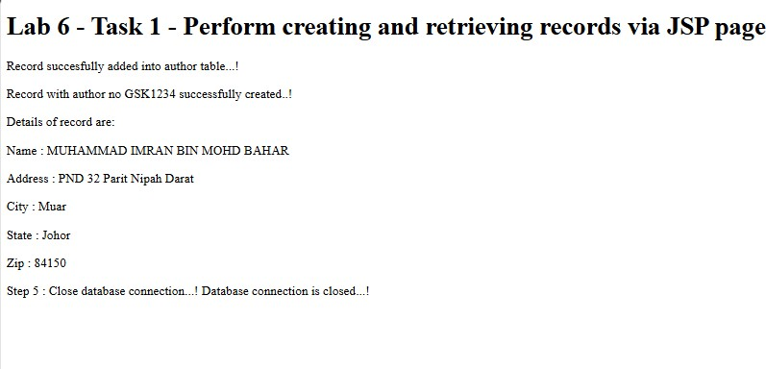

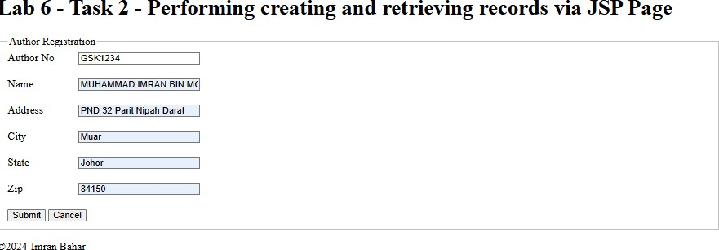

Code:

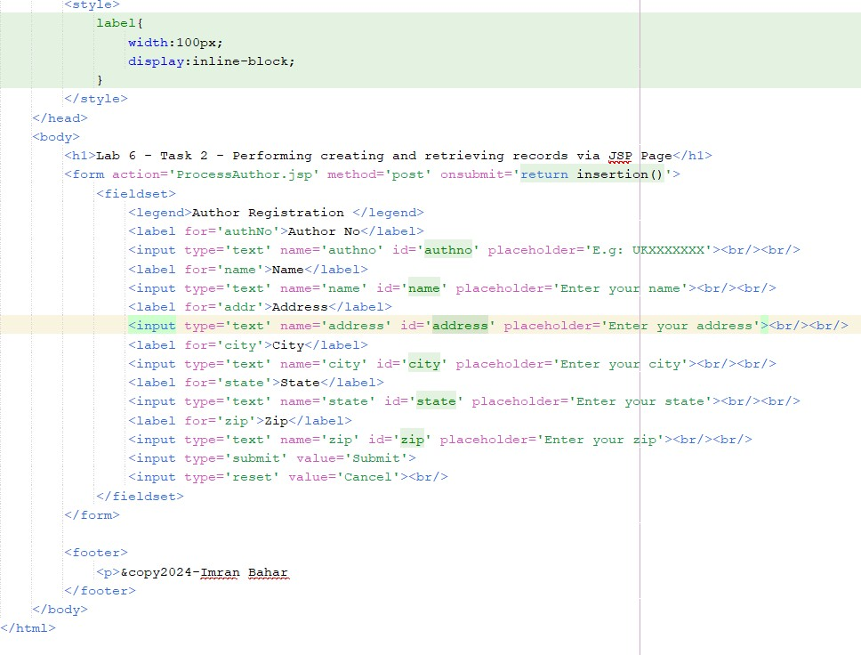

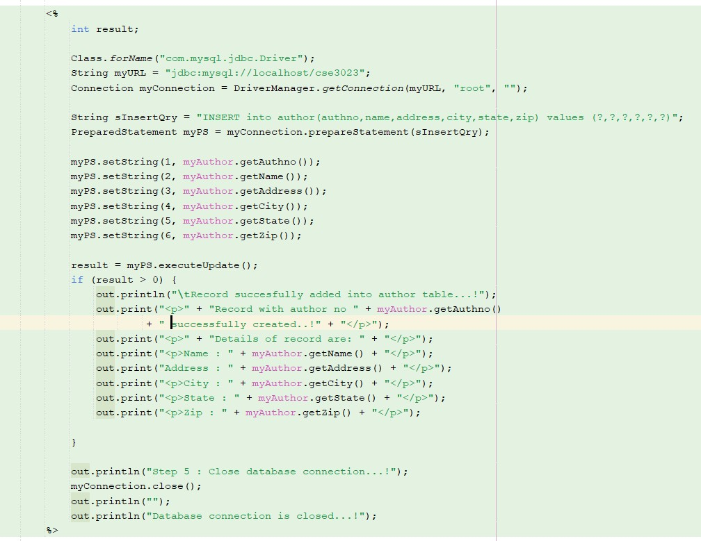

Reflection:

1. What have you learnt from this exercise? How to insert data into database via jsp
2. Define step by step before you successfully perform the transaction in a database.
   1. Create database table
   2. Create jsp for input
   3. Create jsp for process the input into database
   4. Create a output to confirm the database been connect,access,update,view and close

Task 3 Output:

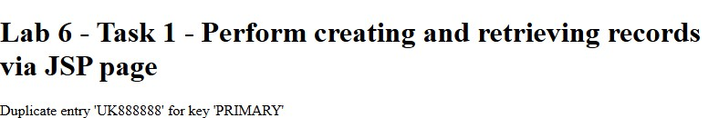

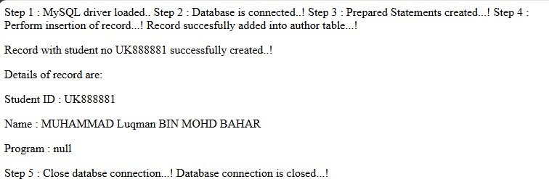

Code

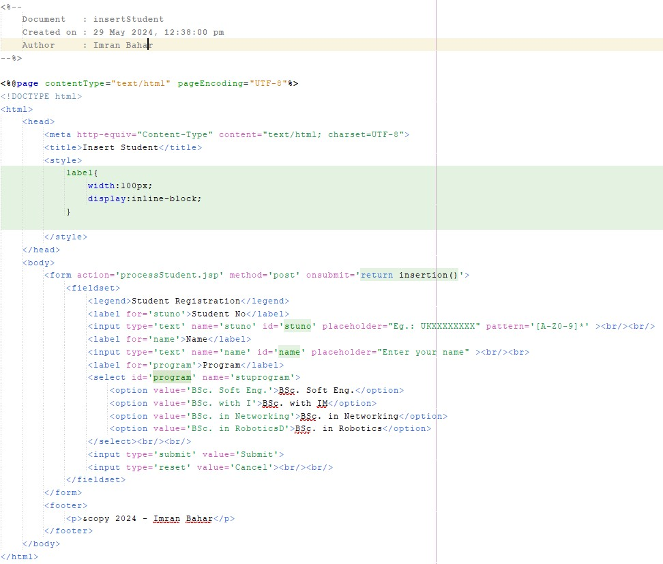

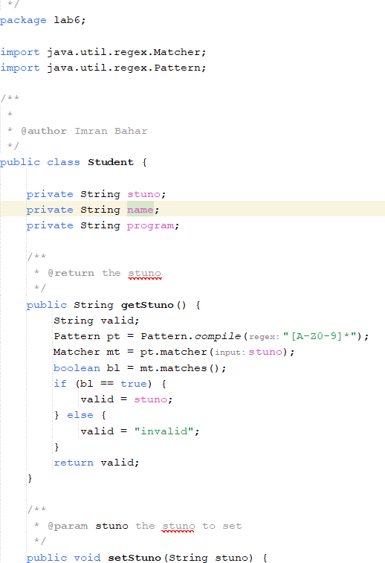

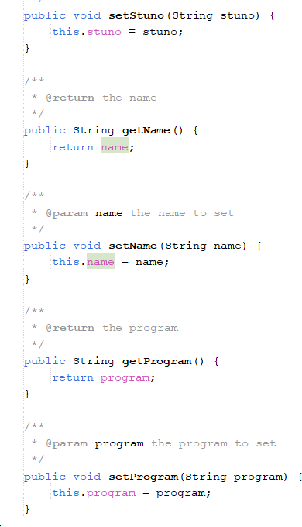

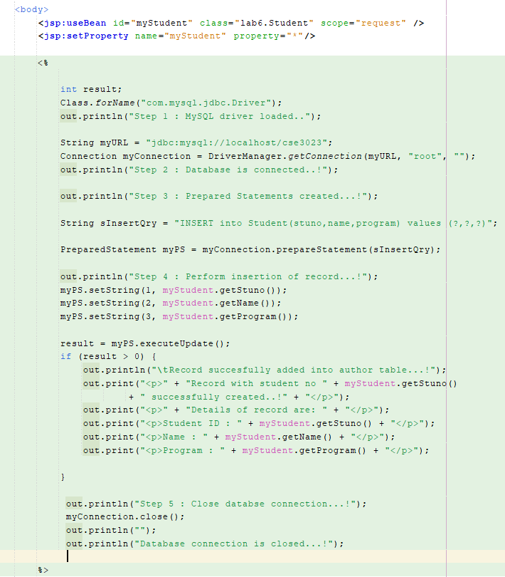

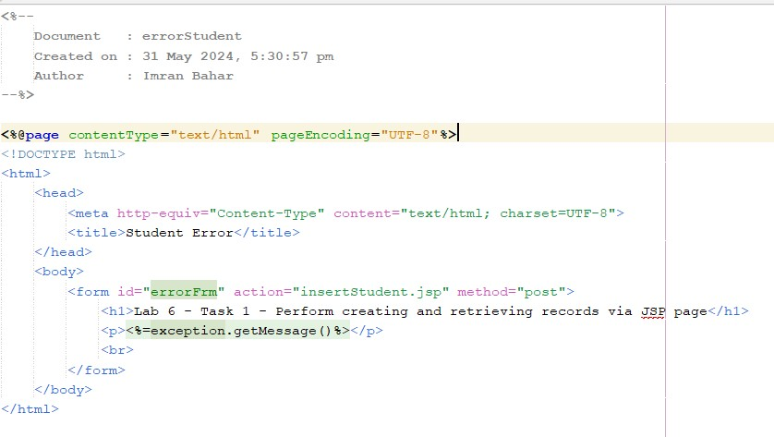

Reflection

1. What have you learnt from this exercise?

How to accept information from user through jsp page form input then pass it to process vis jsp to save inside database.

1. Define step by step before you successfully perform the transaction in a database.
   1. Create database table
   2. Create jsp for input form
   3. Create jsp for process the input into database
   4. Create a output to confirm the database been connect,access,update,view and close

Task 4 Output

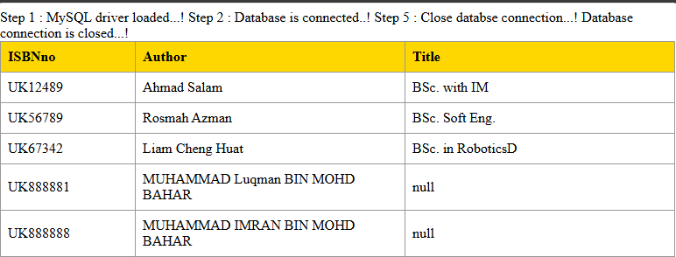

Code

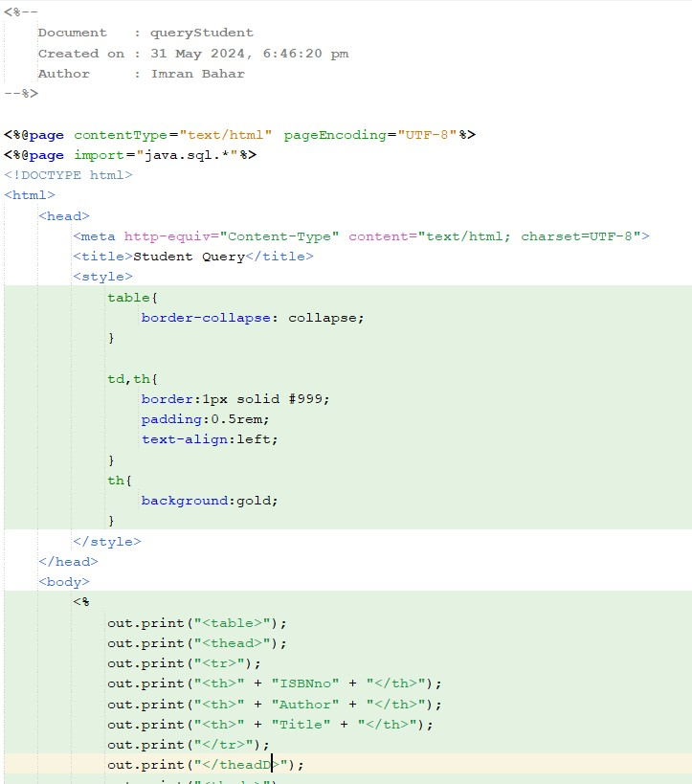

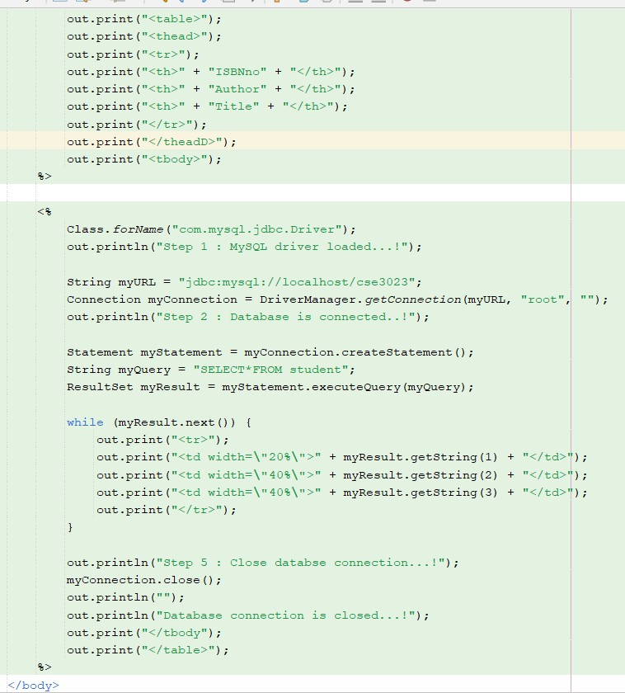

Reflection

1. What have you learnt from this exercise? How to update the database via jsp
2. Explain the differences when using Statement() and PreparedStatement().

Statement is used to access the database while prepared statement when want to use SǪL statement many time.

Task 5 Output:

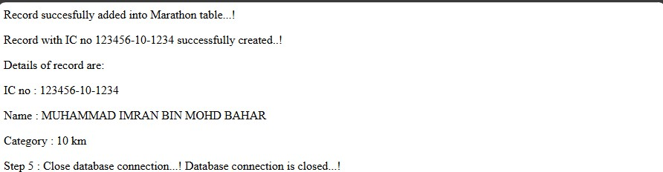

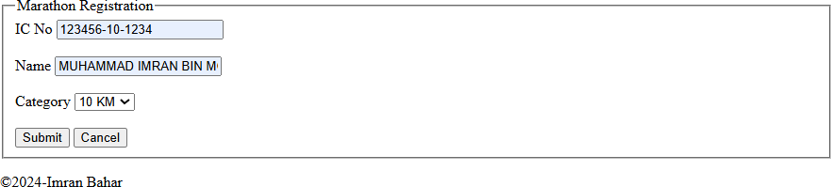

Code:

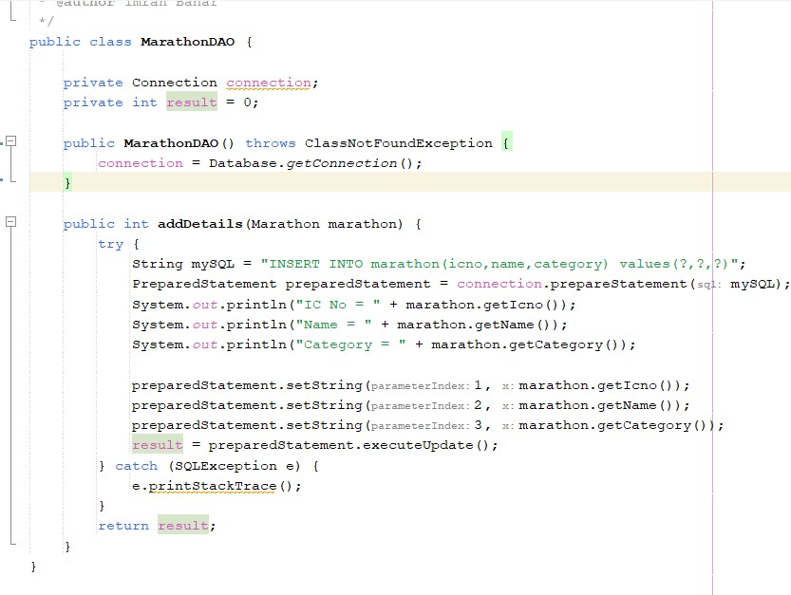

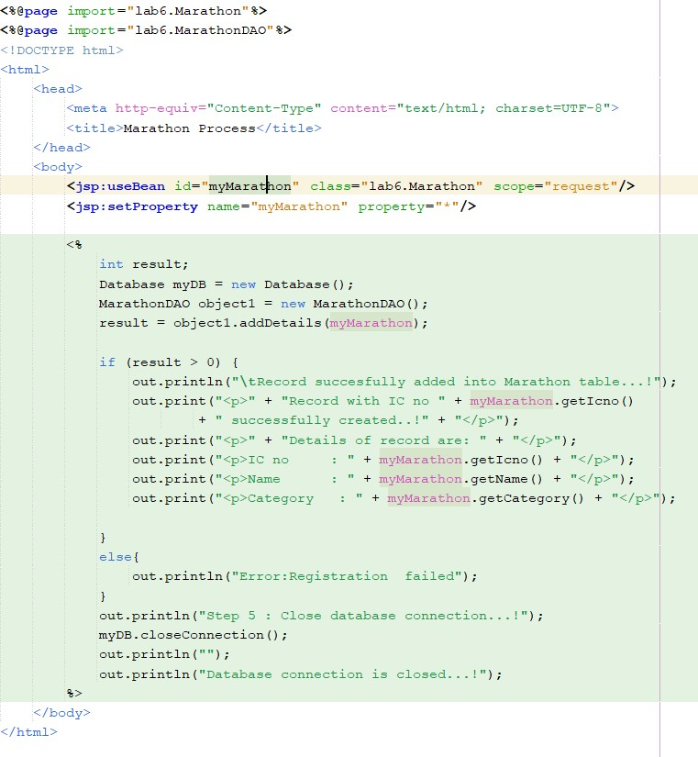

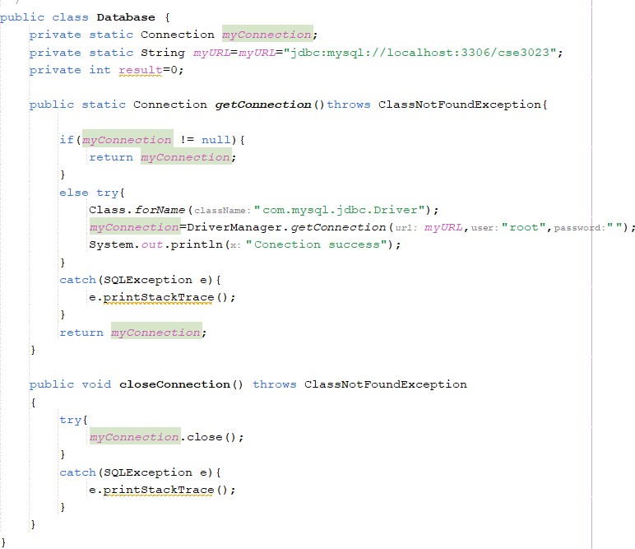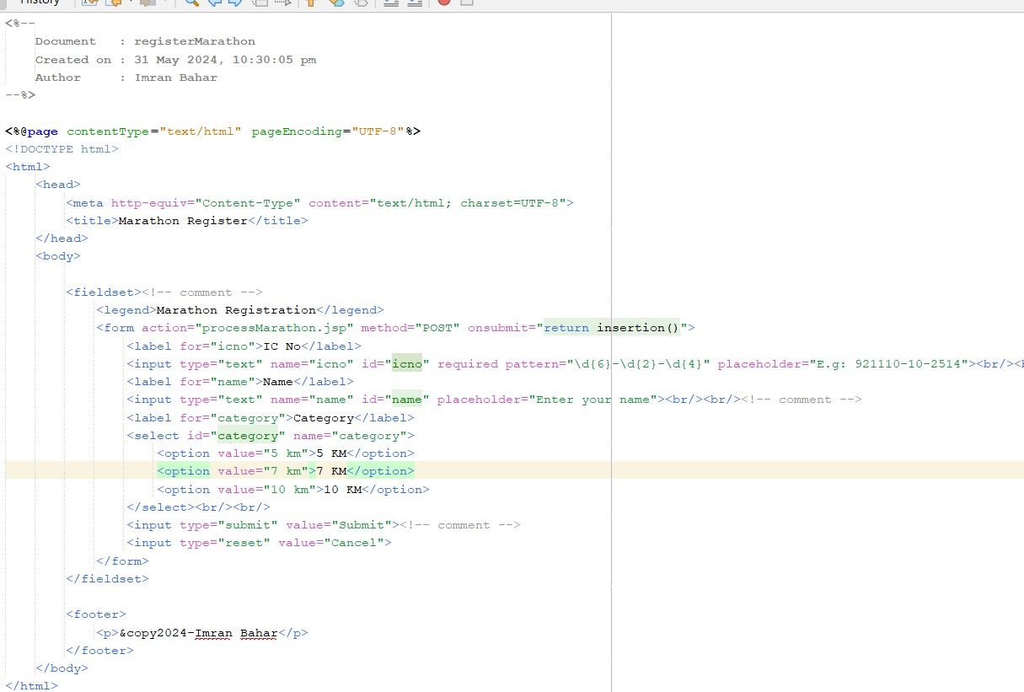

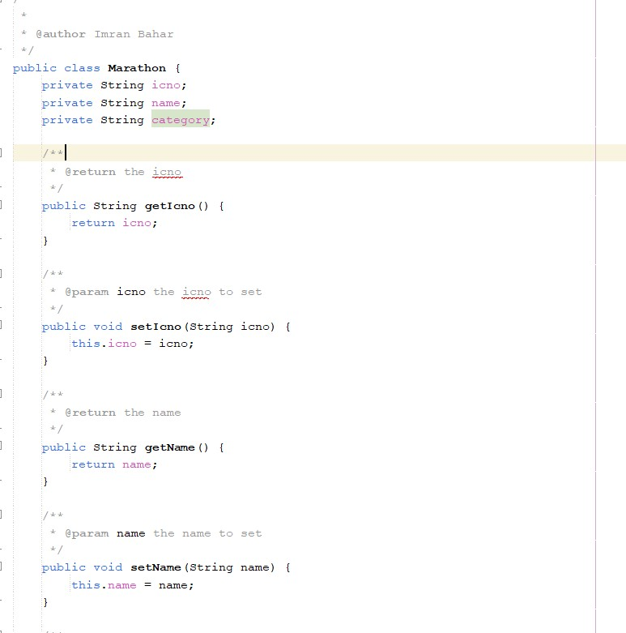

Reflection

1. What have you learnt from this exercise? How to use javabean as logic controller
2. Describe the benefits of using JavaBeans.

We can control the logic controller of the respond and request.

Exercise

1. Create a table known as userprofile using database schema CF3107 using these attributes.

* username as a character length 15 and must be primary key
* password as a character length 10
* firstname as varchar(50)
* lastname as varchar(50)

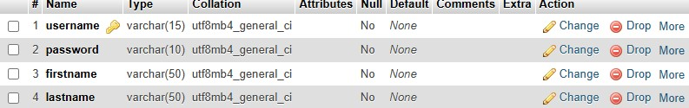

1. 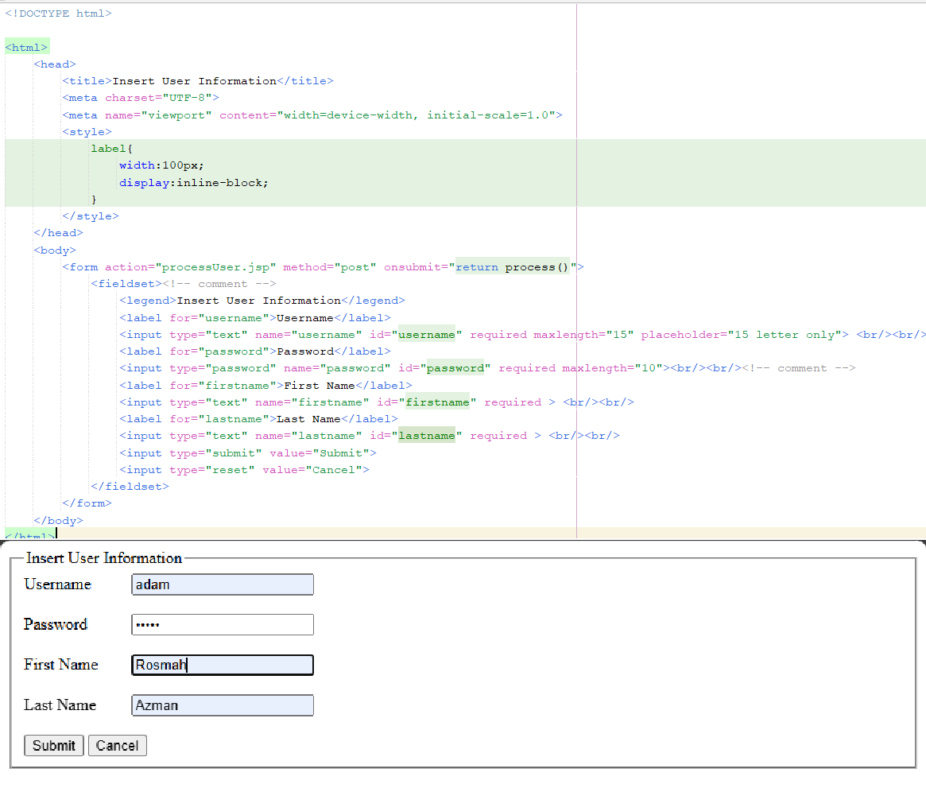Create insertUser.html as the main interface to register a new user
2. Create processUser.jsp page to process the record.

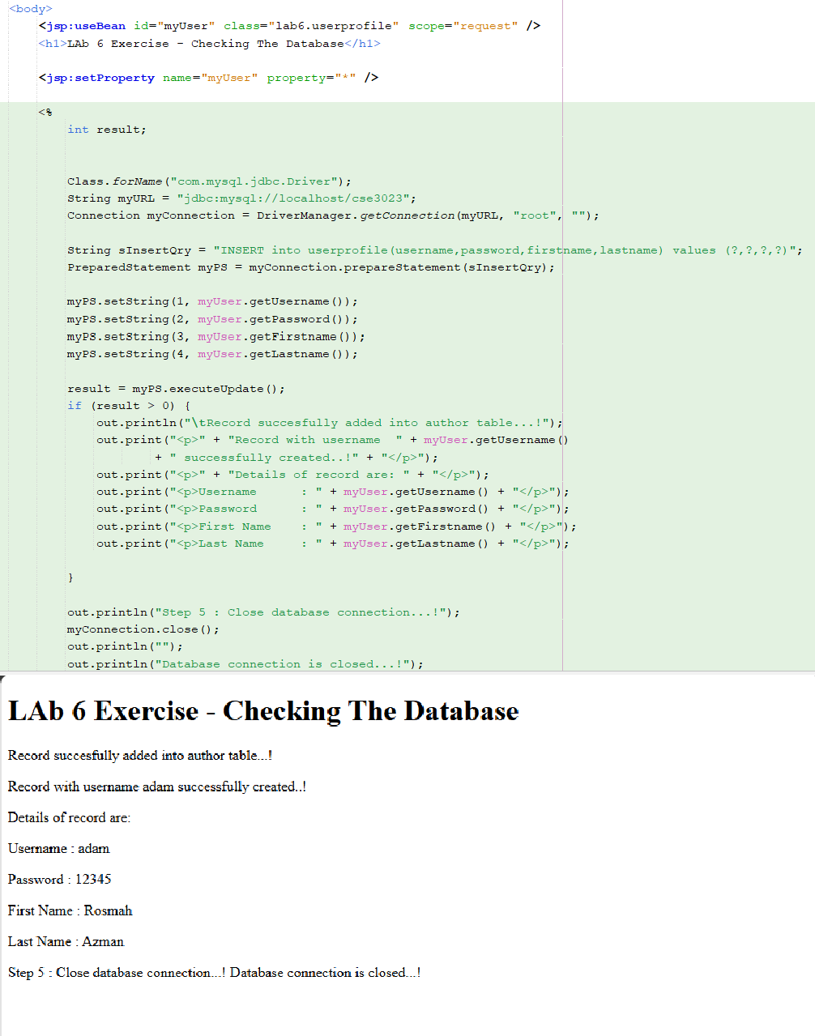

1. 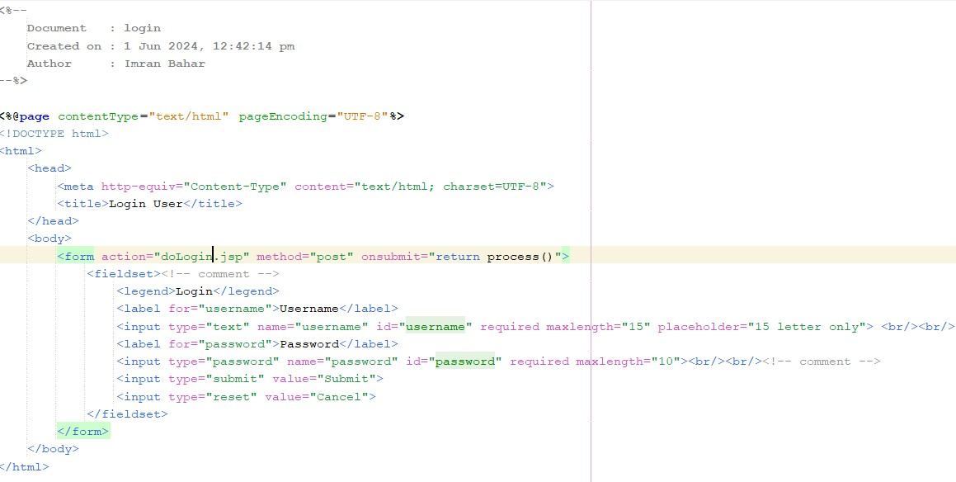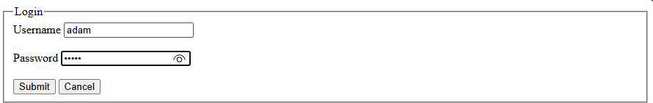Create login.jsp page to login to the system
2. Create doLogin.jsp to validate username and password. If validation is successful, redirect the page to main.jsp page that displays the username, firstname and lastname

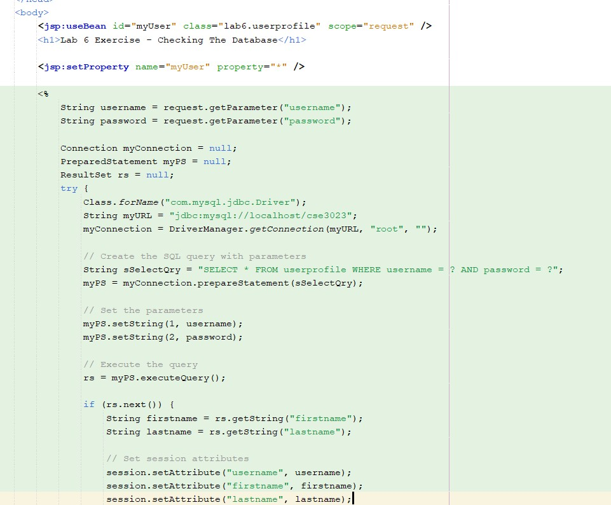

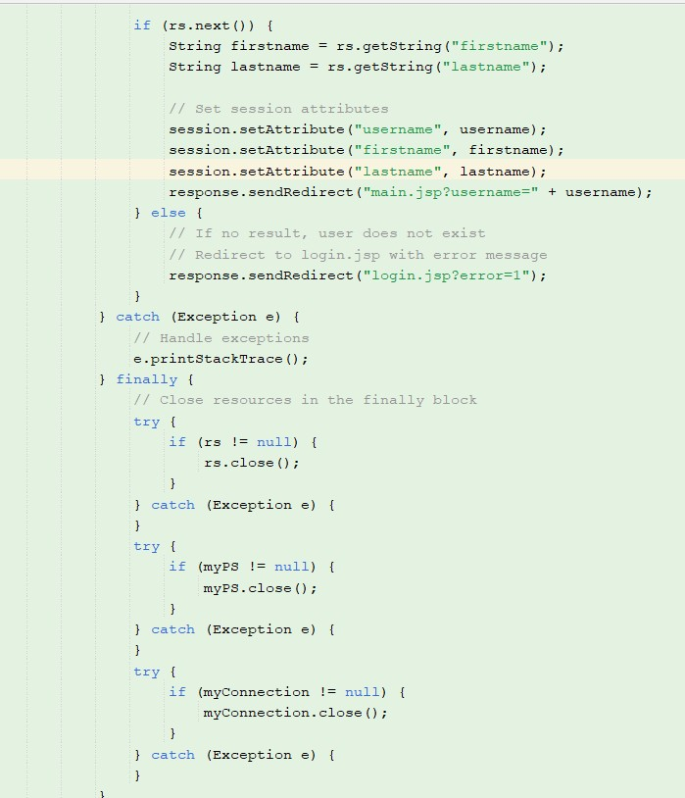

1. If validation is unsuccessful, redirect the page to login.jsp with message ‘Invalid username or password..!

